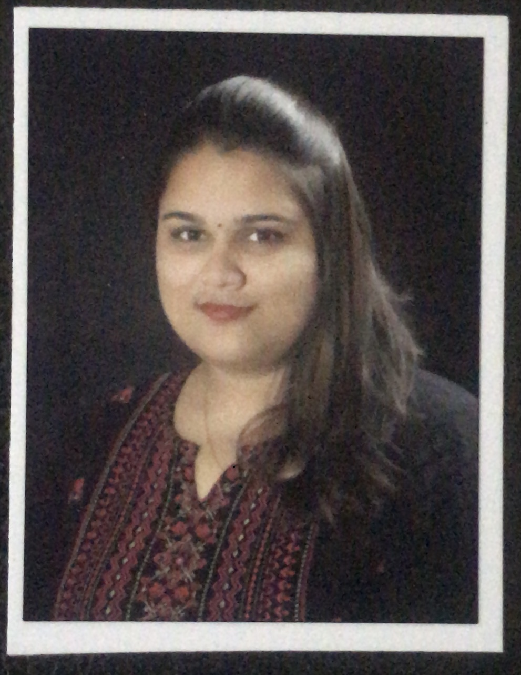 **RESUME**

YASALAPU MEENAKSHI

EMAIL ID : meenu.yasalapu@gmail.com

**CONTACT NO:** +91 8897076294

**CAREER OBJECTIVE**

To be a part of the success story where I can play an important role in achieving new milestones. To strive hard for the overall growth and progress of the organization as well as mine by imparting my knowledge, skills and experience. To reach new heights through my hard work,sincerity and determination.

**EDUCATIONAL QUALIFICATION**

**Course College**

1) SSC Sasi EM High School

2) Intermediate (BiPc) Sasi Junior College For Girls

3) Graduation (M.Sc Integrated Bio-technology) GITAM deemed to be University

Board/University Year of passing Percentage/Grade

1. Board of secondary education 2013 8.8GPA

2) Board of intermediate education 2015 89%

3) GITAM deemed to be University 2020 66%

**TECHNICAL SKILLS:**

OFFICE TOOLS : MS-OFFICE

PROGRAMMING LANGUAGES : C , C++ , JAVA SCRIPT

**PROJECTS**

* ISOLATION AND IDENTIFICATION OF STORAGE FUNGI : CFTRI , MYSOORE
* CATALOUGUING OF GENES IN CATHARANTHUS ROSEUS : GITAM DEEMED TO BE UNIVERSITY , VISAKHAPATNAM.

**STRENGTHS**

* Positive Attitude
* Good Communication Skills
* Confidence and Reliable
* Target Oriented
* Hard Work Nature

**LANGUAGES KNOWN**

* Telugu
* English
* Hindi

**HOBBIES**

* Listening Music
* Watching Netflix.
* Blogging
* Gardening

**PERSONAL PROFILE**

NAME:- YASALAPU MEENAKSHI

FATHER NAME:- Y. UMA RAJASEKHAR

DOB:- 26-10-1997

GENDER:- FEMALE

MARITAL STATUS:- UN-MARRIED

NATIONALITY:- INDIAN

RELIGION:- HINDU

PERMANENT ADDRESS :- DR NO:-53-32-5/14,

KRM COLONY,

SEETHAMADHARA,

VISAKHAPATNAM, 530013.

**DECLARATION**

I request your good self to consider my application favorably and give me an opportunity to

Serve under your kind control. I assure your good self that I would strive hard to bring credit to your esteemed organization. I hereby declare that the information furnished above is true of my knowledge.

Date : Yasalapu Meenakshi Place: Visakhapatnam